**CENG 256**

**Internet Programming**

**LAB 2 part a**

**This lab is to be done in pairs.**

**Learning Objectives:**

1. Understand the use of variables in a program.
2. Understand how expressions are developed.
3. Understand basic debugging strategies.
4. Overview of var, prompt, console.log, alert and selection and looping constructs .
5. Usage of Math.random() and Math.floor() functions;

**Question 1:**

**Part 1:**

Carefully consider the JavaScript below. Make sure you understand how the code works and what it’s output should look like with the person next to.

**var word = "bottles";**

**var count = 99;**

**while (count > 0) {**

**console.log(count + " " + word + " of beer on the wall");**

**console.log(count + " " + word + " of beer,");**

**console.log("Take one down, pass it around,");**

**count = count - 1;**

**if (count > 0) {**

**console.log(count + " " + word + " of beer on the wall.");**

**} else {**

**console.log("No more " + word + " of beer on the wall.");**

**}**

**}**

**Part 2:**

Examine the HTML below. Type in the HTML and then place the JavaScript above in between the <script> tags. You can use an editor like Notepad (Windows) or TextEdit (Mac), making sure you are in plain text mode.

**<!doctype html>**

**<html lang="en">**

**<head>**

**<meta charset="utf-8">**

**<title> First JavaScript Example </title>**

**</head>**

**<body>**

**<script>**

**</script>**

**</body>**

**</html>**

Part 2.1. Create a folder on your desktop labelled as both your id numbers with an underscore(_) between them. Save the file as ***question1.html*** and place it in the folder.

**Part 3:**

Load the file into the Chrome browser. You can do this by simply right clicking on the file in windows and choose open with -> chrome. You will not see anything in the browser. To see the output you must go to the browser console and follow the diagram below. 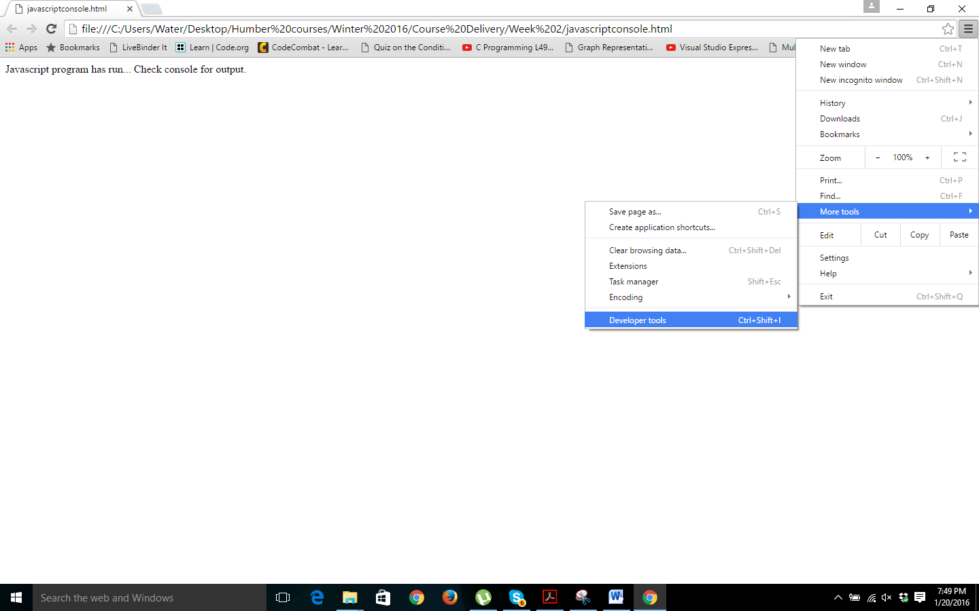

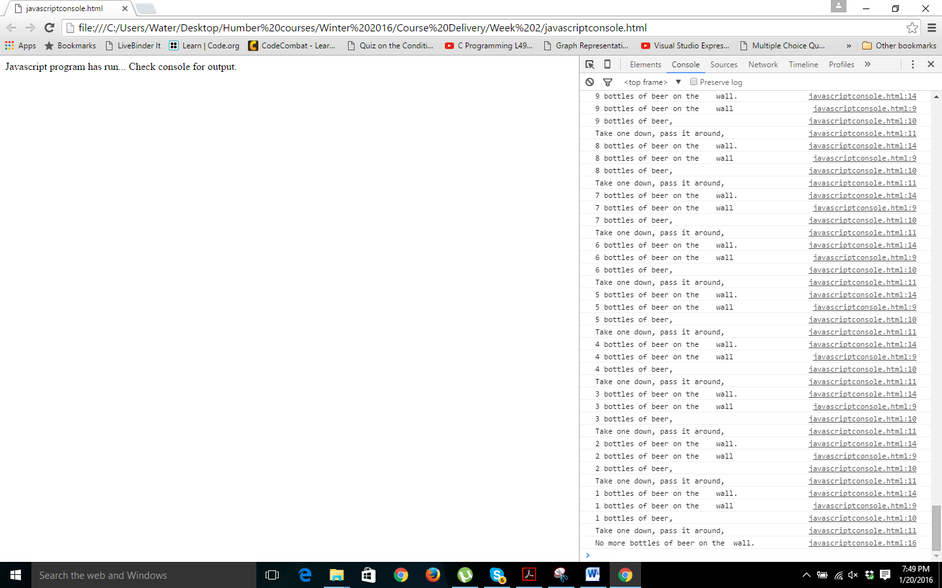

**Question 2:**

Create a simple Battleship game in JavaScript. (**THIS GAME HAS NO GRAPHICS**)

**Part 1:**

Type the HTML below in your text editor and save it as battleship.html in the folder you created on your desktop.

**<!doctype html>**

**<html lang="en">**

**<head>**

**<meta charset="utf-8">**

**<title> Battleship </title>**

**</head>**

**<body>**

**<h1> BATTLESHIP </h1>**

**<script src=”battleship.js”></script>**

**</body>**

**</html>**

**Part 2:**

Type JavaScript code for the game in your text editor and save it as “battleship.js” in the same area as battleship.html. **Make sure and comment you name and id numbers to the top of the JavaScript code!!!**

The game outline is as follows……..

Create and array of with seven (7) zeros in it e.g **var area=[0,0,0,0,0,0,0**];

A **0** represents nothing is at that place in the ocean.

A **1** represents a ship is there.

Place a ship three spaces wide from locations 1 to 3 . The array should conceptually look like:

|  |  |  |  |  |  |  |
| --- | --- | --- | --- | --- | --- | --- |
| 0 | 1 | 1 | 1 | 0 | 0 | 0 |

Using syntax similar to below, ask the user to enter a location from 0 to 6 for a mine.

**guess = prompt("Ready, aim, fire! (enter a number from 0-6):");**

Write a JavaScript program that asks the user to enter locations between 0 and 6, and when all the locations of the ship have been hit, it indicates the number of guesses it took to get there as well as the shooting accuracy. Shooting accuracy will be **3 / guesses**. If it is a **hit** or **miss** you must indicate it to the user. The following declarations can start you off.

var area=[0,1,1,1,0,0,0];

var guess;

var guesses = 0;

var isSunk = false;

Completely test your simple game.

**Question 3:**

Copy the JavaScript code from “battleship.js” into your text editor and save it as “betterbattleship.js” in the same area as battleship.html. Using the Math.random() and Math.floor() functions covered in class, make the position of the ship be placed in a random position. . To get a random number between 0 and 4 let us say we would use :

var x =Math.floor(Math.random()*5);